Steps to Copy Borland DB Editor:
- Extract BDESetup.rar, db4temiss.rar to desktop.
- Navigate to BDESetup extracted folder, double click “BDESetup.exe” to install Borland Database Engine v5.2.
- Click Next to continue until finish.
- Navigate to “db4temiss” extracted folder, copy “db4temiss” folder to “C:\Program Files (x86)” as shown below.
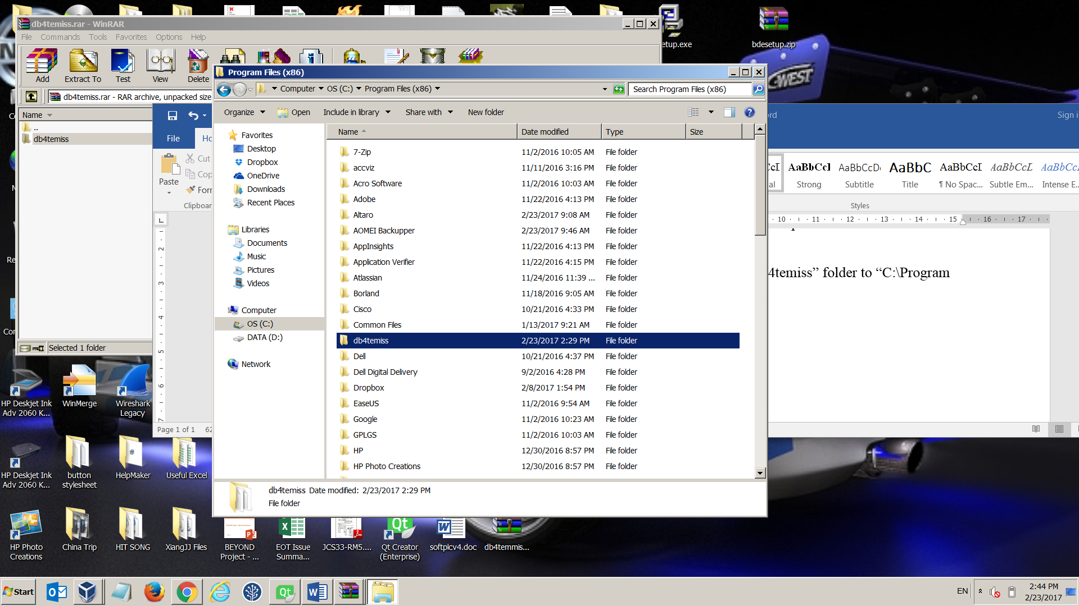

- Navigate to “db4temiss” extracted folder, copy “IDAPI.CFG” file to “C:\Program Files (x86)\Borland\Common Files\BDE\” as below and replace the original file.
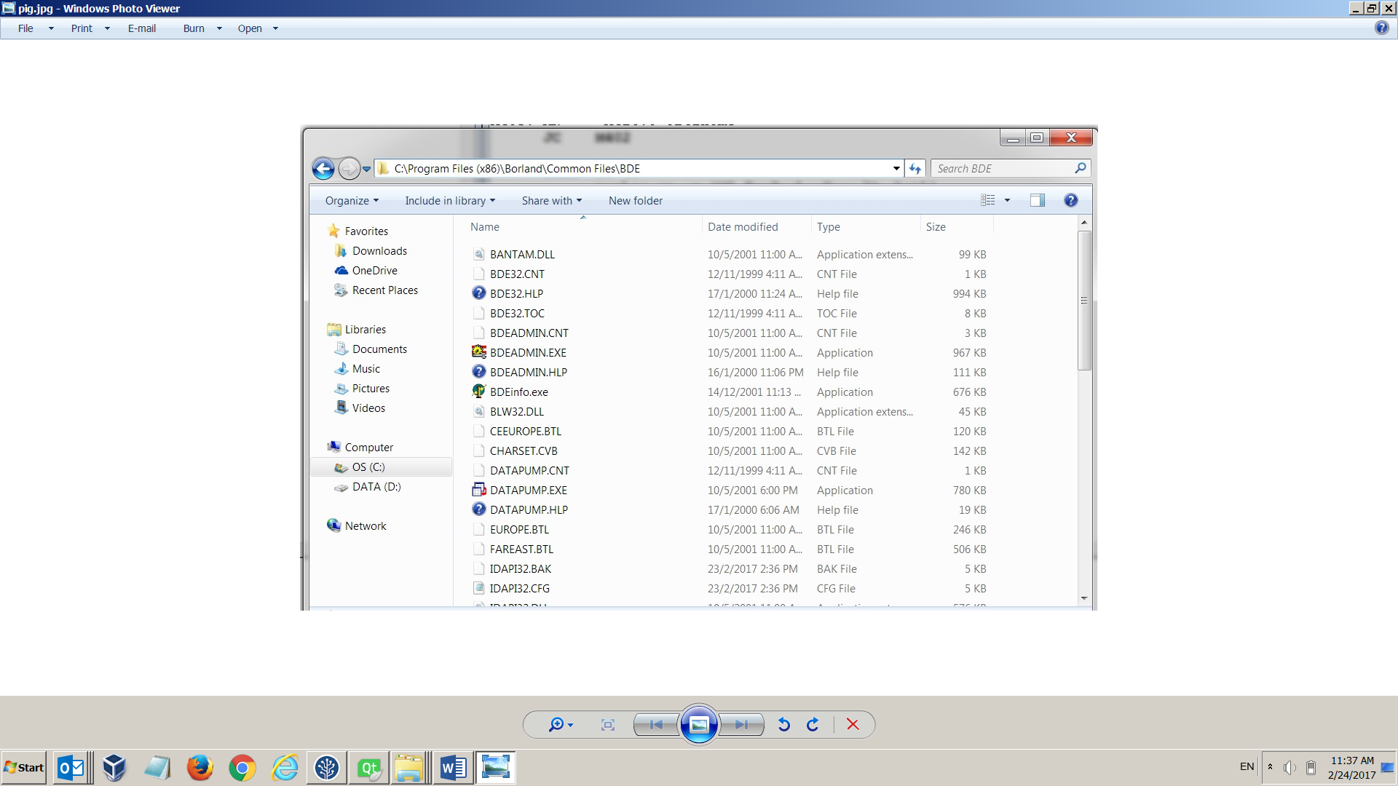

- Launch the program in “C:\Program Files(x86) \db4temiss\DB4TEMISS.exe”.
You can create a desktop shortcut if you want.
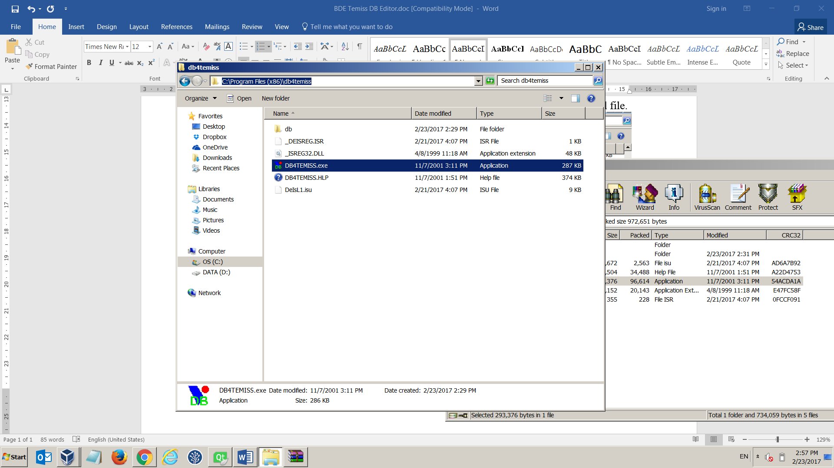

- Copy your DB and start amendment as usual.

